5. List the location number and name of locations that are part of the “Basketball arena”. Your WHERE clause should not have a condition involving the facility number compared to a constant (“F101”). Instead, you should use a condition on the FacName column for the value of “Basketball arena”.

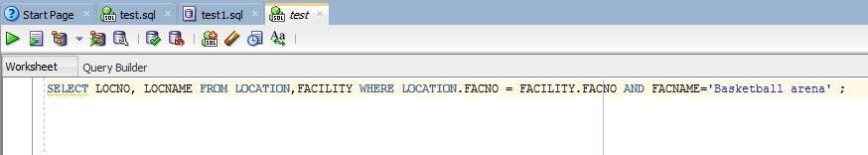

SELECT LOCNO, LOCNAME FROM LOCATION,FACILITY WHERE LOCATION.FACNO = FACILITY.FACNO AND FACNAME='Basketball arena' ;

